**Assignment - 3**

**Student Name:** Vivek Kumar **UID:** 21BCS8129

**Branch:** BE-CSE (LEET) **Section/Group:** ON20BCS-809/A

**Semester:** 4th Sem **Date of Performance:** 04/05/2022

**Subject Name:** MPI **Subject Code:** 20CSP-252

**1. Aim/Overview of the practical:**

Analyze the working of instruction queue in 8086?

**2. Theory:**

**Prefetch Queue:**

1. Prefetch queue: It is 6-byte First-In-First-Out (FIFO) queue which can store up to 6 instruction bytes.
2. The BIU fetches instruction bytes from memory ahead of time and stores it in prefetch queue.
3. Whenever execution unit completes execution of previous instruction, it receives next instruction from queue and starts executing it.

**Advantage:**

1. As next instruction is readily available in queue, EU need not wait for fetching the instruction. This saves considerable time and speeds up execution.
2. The concept of fetching instructions ahead of time and storing it in queue which is used by EU whenever it is free, is known as pipelining.

**Working of Prefetch:**

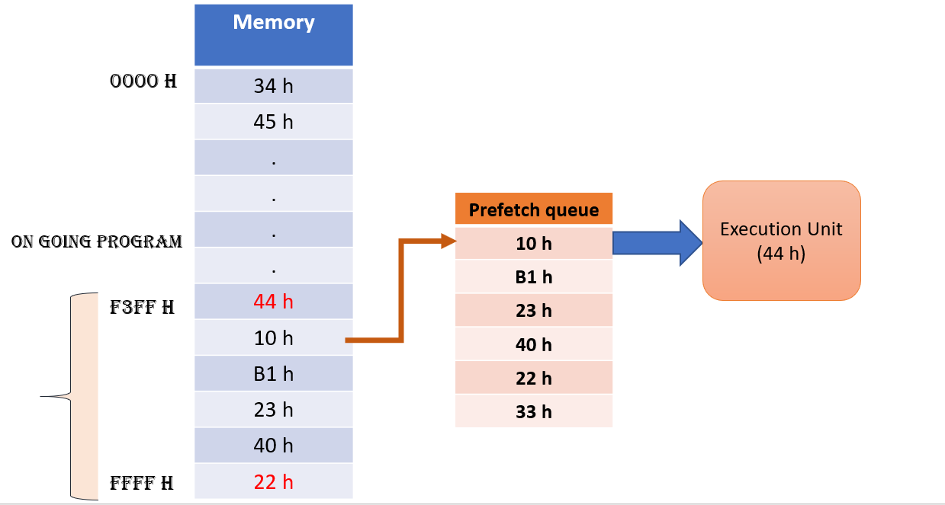

**Prefetch Queue & Branching Instructions:**

1. The BIU fetches instructions in sequence which causes problem when JMP or CALL instruction comes.
2. In case of JMP or CALL, the execution will not continue in sequence, but the control will be transferred to target of JMP or CALL and execution should continue from new location.
3. To avoid this problem, whenever execution unit executes JMP or CALL Instruction. Prefetch queue is made empty and it is filled up again from new location.

**Working of Prefetch Queue during JMP & CALL:**

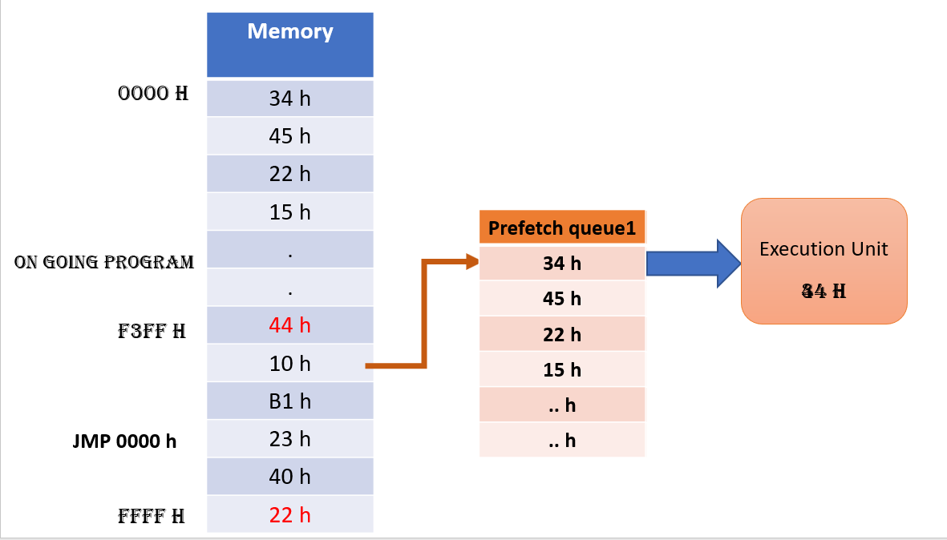

**Evaluation Grid (To be created as per the SOP and Assessment guidelines by the faculty):**

|  |  |  |  |
| --- | --- | --- | --- |
| Sr. No. | Parameters | Marks Obtained | Maximum Marks |
| 1. |  |  |  |
| 2. |  |  |  |
| 3. |  |  |  |
|  |  |  |  |